Summary of existing LabView code sequence
The Q-Switch triggers are square pulses generated by Ch 1 of the Rigol digital generator DG1022Z, which are externally triggered by flashlamp firing triggers and delayed by an amount required to maximize the output laser energy. The DG1022Z gets an external trigger that comes from the Agilent generator to maximize laser power? In the current configuration the Q-SW trigger input (external trigger) source is the combined flashlamp input trigger signals coming from the Agilent and the SRS DG645 (which generates the last pulse). The Q-switch delay relative to flash lamp is maintained to maximize laser output energy.
The Agilent creates a pulse train equal to the number of pulses that are needed to span the timeframe between T0 and the end of the warm up phase For N warming up pulses and the last pulse at t = 36.5 ms, we need to set the start of warming up flashlamp triggers at –((0.1 * (N+1) + 275 e -6 + 60 e-6) + 36.5e-3) s. Note the slight deviation from 10 Hz pulse repetition rate for the last laser pulse is acceptable. Then when it is done making that pulse train, the laser stops firing the flashlamps and is waiting for a new flashlamp pulse. That new pulse currently comes from the SRS DG645 and is delayed relative to the external trigger it receives by a time equal to the time from when that second trigger was sent out minus the time between flashlamp firing and Qswitch. The actual delay between the Agilent and DG1022Z pulses is the programmed delay time (typically 60 microseconds to maximize laser power plus an additional fixed fire-to-Qswitch delay (274.4 us or 275 us for Qsmart. This additional delay is added to the nominal Q-switch delay we are familiar with.
In other words, let’s say you wanted your laser to fire at 36.5 ms after the second trigger is received. You would delay the SRS DG645 a total of 36.5-0.06-0.2744 = 34.166 ms from that trigger so that the QSwitch (with the user supplied delay of 60 microseconds) would fire at 36.5 ms and the flashlamps would fire 334 microseconds before that. Figure 52 of Shi’s document calls this second trigger the gas puff trigger. It is actually another trigger (called “ICCD AUX”) that is the rising edge of the plasma gun arc trigger but is very long (to span the entire discharge) and is used to hold open the camera shutter. In Shi’s document, one must calculate when that trigger is to arrive and compensate for the actual laser firing time target.
Once the laser actually fires the last pulse, the Q-Switch synch pulse from the laser (the “laser actually fired signal” is combined with the iCCD signal in an AND gate and that then fires the iCCD in the Andor camera. The camera takes some time to open its shutter and by that time the light from the laser has arrived and is recorded. One subtle detail is that this “gun arc trigger” is not directly the trigger signal of gas injection circuits but a signal called ICCD AUX, which starts together with gas injection trigger and lasts much longer to cover the whole plasma pulse.
Therefore, the DG1022Z is intrinsically delayed from the input signal from the Agilent or the DG645 and the delay is same among warming up shots and the last laser shot. If that is the case, how it gets delayed is a mystery. For the parallel TS, the Q-switch sync output from Qsmart-850 is used to AND with gun arc trigger for the iCCD trigger.
One long BNC cable runs from the parallel laser to the iCCD input on the laser table to transmit the Q-switch sync output signal. This long cable run adds an extra delay on the order of 10s ns. This is why the DDG gate delay values (in LabView) for parallel and perpendicular TS are different (~ 150 ns). Currently, these two Q-switch sync outputs are not teed together but are interchanged manually when changing between TSs.
CH2 of the DG1022Z on the perpendicular TS system is used for the Qsmart-850 laser of the pulsed dye laser for LIF. NOTE: in the LabView code, the TS-Quanta Ray control panel is actually for parallel TS.
In conclusion, there really is no need for a SRS DG645 in this timing sequence. We can just send all the desired triggers from the SRS DG645 in the master triggering system (warm up sequence, open iCCD shutter, and fire laser – only this last trigger would need to be different for the two TS lasers. To fire the LIF laser at a different time would just require two more final pulse triggers for the flashlamp and Qswitch for that laser (or one processed with another delay generator to give the 60 microseconds delay).
Existing Definitions
Warm-up: how long the laser starts up before the gas puff pulse and runs the flashlamp and Qswitch triggers. This defines how many total pulses to send out from the flashlamp and Qswitch trigger systems? So 32 s x 10 Hz = 320 pulses?
Gap: Historical artifact. According to Shi, no longer needed or implemented in the LabView code.
Pulse time: The time after the gas puff that is targeted for when the laser should fire by sending the Q-switch signal. So this should be equal to the time between the gas puff initial trigger and the arc pulse plus the length of time between firing the arc pulse and the bias pulse plus the length of time into the bias pulse that you want TS data plus the intrinsic Fire-Q-switch delay of 274 microseconds plus the intrinsic delay of 1 microsecond of the circuit response. So if T0 is when the initial master trigger happens, the desired laser firing time from
T0 = 30 s (laser warm up time) + .035 s (Gas puff to arc delay) + 0.013 s (Arc to bias pulse delay) + 0.0002744 s (intrinsic laser flashlamp to qswitch delay) + 0.000060 s (user requested flashlamp to Qswitch delay to optimize power) + 0.000001 s ( intrinsic circuit delay).
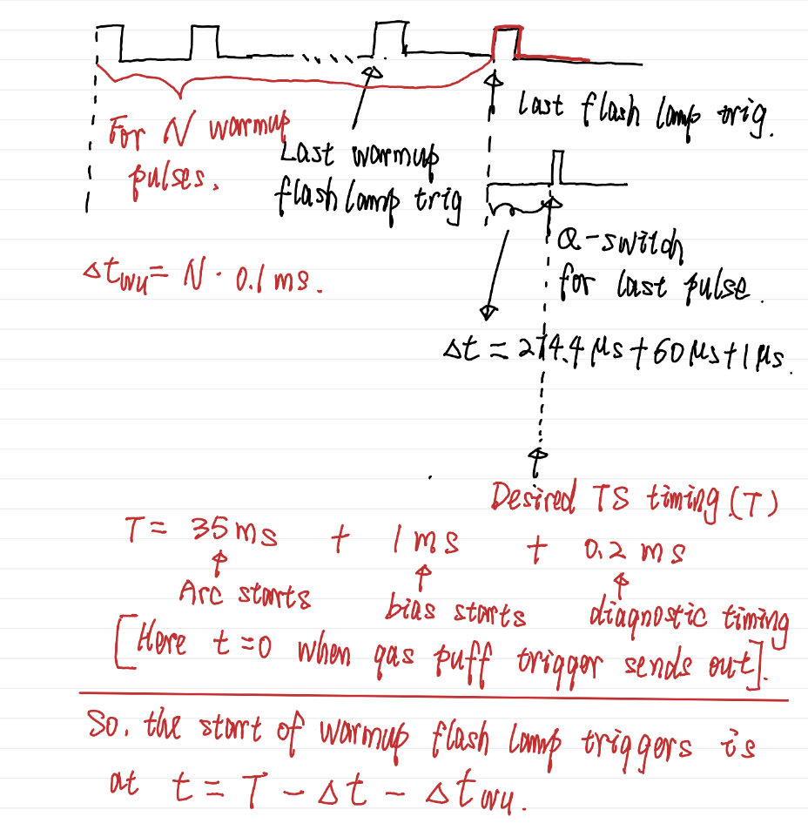

Pulse frequency: repetition rate of the flashlamp and Qswitch pulses that are sent to the two laser power supplies for the Q1500.
Q-switch delay: The time between the rising edges of the flashlamp pulses and the Qswitch pulses. This is set to optimize the laser power. ? Q-switch delay is same for all laser pulses including the last pulse. The firing time of last lase pulse is determined by timing of the last trigger of flash lamp.
Fire to Qswitch: The Q-switch delay on the touch panel does not include some delays listed below. The value 274.4 us is determined by obtaining maximal energy when Q-switch delay is set at 7 us (maybe).
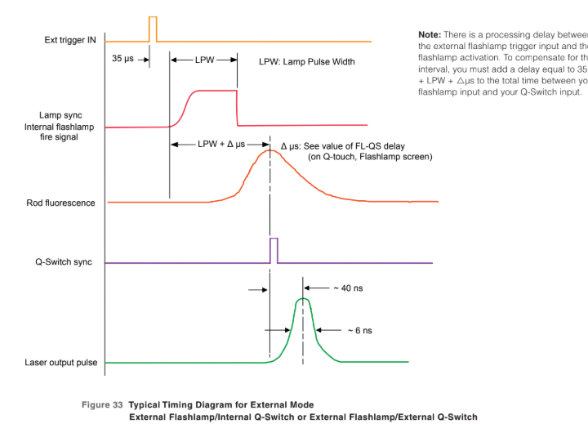
Delta t: Custom circuit response times contributing to the delay calculation. Since the original system used the iCCD Aux trigger and we plan to use a new trigger, this delay may need to be decreased.

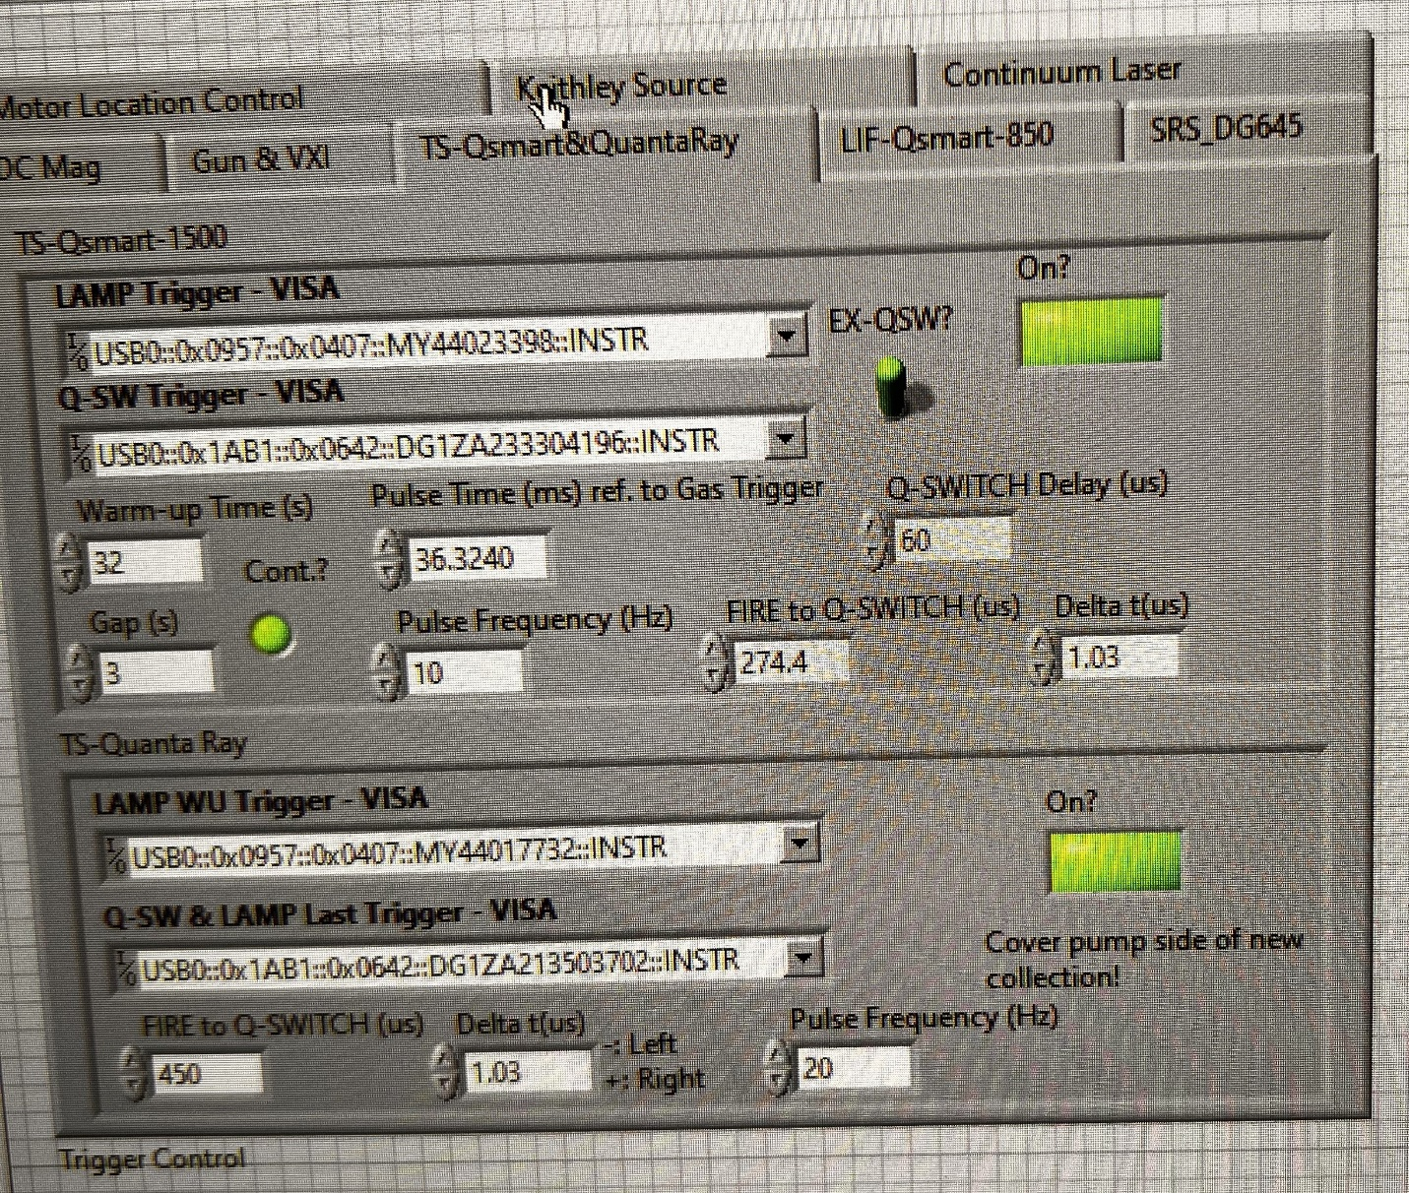
.

Proposed New Code Process
Step 0
If and only if the activate switch is flipped on the main control panel, launch the LabView executable that runs the lasers in the background on a slow simmer. The delay between the Q-switch and the Rigol is stretched out so the lasers are firing at pretty low power. When the activate switch is turned off, turn off the background simmer sequence? Will this return the lasers to full power? Probably not if deactivating them does not turn on any external pulse sequencing. Better make sure an errant master trigger pulse cannot turn the lasers back on. Perhaps overwrite the flashlamp and Qswitch trigger amplitudes to zero Volts at this step? If so, then when activated, have to return them to 1 volt.
Step 1
When the TS settings window is opened and then the values saved, read all the pulse frequencies, delay times, etc. from the front panel. The time to fire the laser in the middle of the bias pulse could be set here or in the master trigger panel. In the code, we will subtract off the flashlamp-to-Q-switch delay, the intrinsic Fire to Qswitch delay, and the circuit response delay. So the actual trigger time gives us a Q-switch pulse at the desired time. This trigger time will also appear in the master timing trigger plan. The plan will be to set them in both places and no matter what, the code updates them in both places. We will call the laser firing time “time from bias trigger for laser firing.” We will also define a new trigger time which will be the Andor camera shutter trigger time. By creating this third trigger, we separate out the firing and gas puff sequence of PHASMA from the camera shutter. At this step in the code we will also calculate the total number of pulses that the Agilent will produce based on the time from the master trigger panel to the gas puff and then the time from the gas puff trigger to the bias pulse trigger time. For example, if those values are 30 seconds plus 36.2 ms, we would program the Agilent to generate 300 pulses. That would leave a .0362 second gap between the last flashlamp pulse and the bias pulse. Note, need to make sure that the last of the pulse train and the “final” pulse are still about 100 ms apart to give capacitors time to charge. This may mean backing up or advancing the T0 trigger to get the right number of pulses to line up.
Here also read the visa addresses of all the instruments and set up the acquisition parameters for the Rigol Scope that records the laser trigger signal and the laser power from the photodiodes on the optical table and on top of pumping station. Set this scope to trigger using a digital D0 trigger. Also set up the parameters for the iCCD camera including different DDG delays for the parallel and perpendicular TS systems based on how far the Q-synch signals have to travel to the camera. Note – here in the panel remind the user to physically swap the Q-synch cables until they are permanently coupled through diodes (will need to check that combining the Q-synch signals does not introduce an unacceptable delay in triggering the Andor camera)
Here also have the option to move the central wavelength of the small McPherson spectrometer so you can look at different parts of the TS spectrum if desired.
Step 2
In the arming step of the PHASMA cycle sequence send the timing information to the Agilent and Rigol delay generators for the laser chosen (parallel or perp). Could set them both as a matter of course and then it just matters which laser is turned on for which one fires. Essentially these commands will be to set up the number of pulses to be created by the Agilent system and at what frequency, the delay for the Rigol DG1022Z between an external trigger it receives and the pulse it sends out the front (this will be the optimal delay to maximize the laser power).
Still in the arming step, write a string to the file read by the other TS code to tell the laser to switch from background simmer mode to be in the "experimental mode" In-EXP. This other code runs continuously in the background and changes the timing settings on the Agilent and Rigol devices on both the parallel and perpendicular TS lasers. The timing pulses for the QSmart1500 are teed off to the LIF Q850 laser on the same table
Also still in the arming step, write all the TS system parameters to the MDS system using the same tree paths as Peiyun set up.
Step 3
Arm the Agilent and the DG1022Z (no arming of the SRS DG645 as we are assuming here that it has been pulled out of the system). Arm the Rigol Oscilloscope and the Andor camera.
Step 4
Now in the primary trigger sequence of the PHASMA cycle. Switch the mode of the laser by updating the string in the file to tell the background TS code to stop. Then fire the master trigger T0. This will start the many hundred pulse sequence of the Agilent. The laser stops firing when the last of the pulse train hits. Concurrent with the gas puff trigger, send a different trigger we will call “Andor Camera Shutter Trigger” that lasts for 150 ms (long enough to cover the gas puff and the entire plasma gun sequence). This same trigger could be used to trigger the photron camera shutter. Fire the gas puff, fire the arc pulse, and then fire the “Laser-Firing” trigger, and then fire the bias pulse trigger. Given all the delays that have to be built into the laser firing time trigger (274+60+1=335 microseconds), it will have to come before the roughly 100 microsecond long bias pulse begins. When the laser actually fires (the Q-synch signal), that trigger is combined with the Andor Camera Shutter Trigger (which is still held high) and the iCCD camera fires after the programmed DDG delay of hundreds of ns and then is held open for 50 ns or so.
Step 4
After the pulse ends, write the string to the file again so the laser simmer code starts running again.
Move the Rigol oscilloscope data to the PC and store a plaintext version and push the Rigol data to MDS.
Create a wavelength array based on the parameters of the small McPherson spectrometer. Move the Andor data to the PC. Store the wavelength array and the Andor data in a plaintext file and push those data to MDS.
Step 5
TS process ends.

